

PROJECT OVERVIEW
The objective of this project is to analyze the sales performance of a Superstore across different regions, categories, customers and ship modes using Tableau.
The dataset provides key metrics and insights that help in data-driven decision making.
---
SUPERSTORE
SALES ANALYSIS DASHBOARD


METHODOLOGY





Data Collection Data Preparation Analysis Dashboard


DATASET OVERVIEW

- Source : Sample Superstore (Tableau)
- Records : 9,994
- Fields : 21
- Data Type : Orders, People, Returns

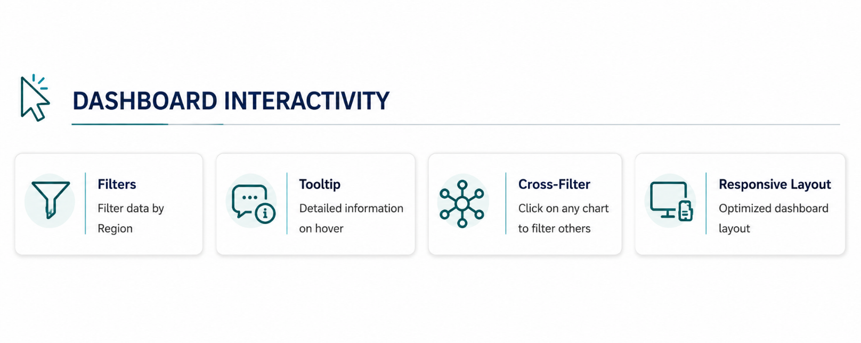


DASHBOARD OVERVIEW

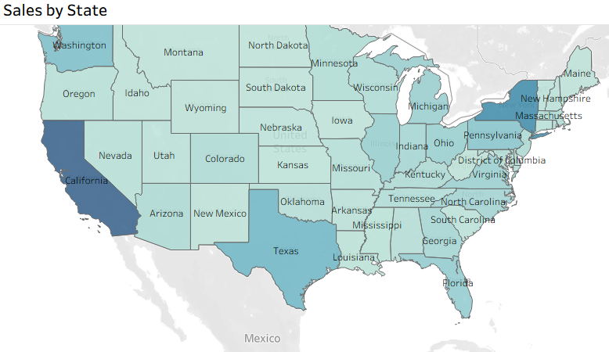
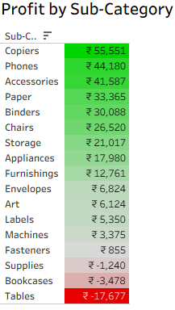
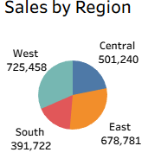
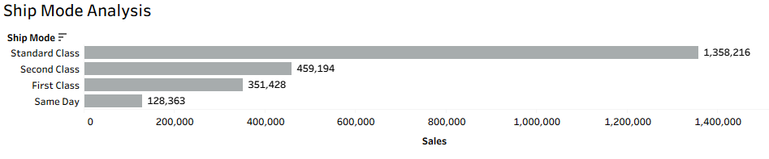
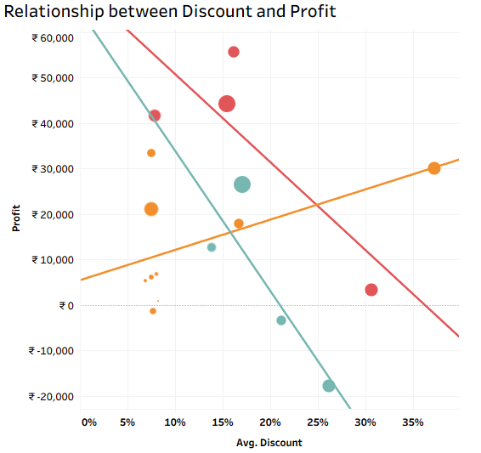


SKILLS AND TECHNOLOGIES USED

Technologies
- Tableau Public
- Microsoft Excel
- Sample Superstore Dataset
Technical Skills
- Calculated Fields
- KPI Design
- Interactive Dashboard
- Filters & Tooltips
- Dashboard Formatting
- Data Visualization
Visualizations
- KPI Cards
- Line Chart
- Area Chart
- Filled Map
- Tree Map
- Scatter Plot
- Pie Chart
- Highlight Table
- Horizontal Bar Chart
- Stacked Bar Chart
Analytical Skills
- Sales Analysis
- Profit Analysis
- Customer Analysis
- Regional Analysis
- Category & Segment Analysis

KEY INSIGHTS

- Sales increased during later months.
- The West Region generated highest sales.
- Technology was the highest selling category.
- The Consumer segment contributed the largest share of sales.
- Standard Class was the most frequently used shipping mode.
- Higher discounts were often associated with lower profitability.
- A small number of customers generated a large portion of total sales.
- Profitability varied across product sub-categories.

- PROJECT SUMMARY
I Developed an interactive Superstore Sales Dashboard using Tableau Public to visualize sales performance, profitability, customer behaviour, and regional trends. The dashboard provides clear business insights through KPIs and interactive visualizations.

